Injured Worker’s First Fill Prescription Form
Administered by CorVel (800) 563-8438

Injured Worker’s Name:
SS#:
Date of Injury:
Injured Worker Instructions:

On your first Pharmacy visit, please give this notice to any local pharmacy to expedite the processing of your approved workers’ compensation prescriptions, based on the parameters established by Puget Sound Worker’s Compensation Trust. With the CorVel pharmacy program, you do not need to complete any paperwork or claim forms. Simply present this CorVel First Fill Prescription Form to the pharmacy with the top filled out. You should not incur any costs or co-pays at the pharmacy and you will be allowed up to a 10-day supply of medications.

Pharmacist Instructions:

Please use the BIN, PCN, and RxGroup number below to process an online/electronic claim to CorVel:

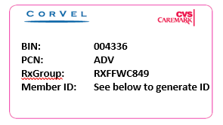

To Generate Member ID: The Injured Worker’s 9 digit Social Security Number plus 8 digit Date of Injury will be used as their 17 digit Member Identification number when processing their First Fill Prescription: XXXXXXXXXMMDDYYYY

***Please contact CorVel Pharmacy Solutions at (800) 563-8438 for assistance with claims processing***

Please visit your local pharmacy to get your prescription filled. There are over 65,000 Participating Pharmacies in the CorVel Network. Call (800)563-8438 for a complete listing.

